K-Medoids Robustness to Outliers in Management Data
Bunga Apriana Gultom, Fanni Maria Dortua Tampubolon, Theresia SU Tanjung
Faculty of Computer Science, Information Systems, Catholic University of Santo Thomas, Medan,
Indonesia
E-mail: bungagultom8@gmail.com , tampubolonfann@gmail.com , theresiaqueenly@gmail.com .

Abstract. This study examines the robustness of the K-Medoids algorithm to the presence of outliers in management data derived from Airbnb property listings, focusing on price and review rating attributes as key indicators in market segmentation and managerial decision-making. The increasing use of data from digital platforms is often accompanied by the emergence of extreme values that have the potential to disrupt the cluster structure and reduce the reliability of the analysis results. Therefore, a clustering method is needed that is able to maintain the stability and consistency of results even though the data contains outliers. This study uses a quantitative and experimental approach based on secondary data, where the implementation of the K-Medoids algorithm and visualization of clustering results are carried out using Python programming, while manual calculations based on Excel spreadsheets are used as a means of conceptual validation of the medoid selection process and distance measurement. The analysis is carried out by comparing the cluster results before and after the presence of outliers using the Manhattan distance metric and evaluating the total cost function at each iteration. The results show that although extreme values in the price attribute cause a wider spread in the data, the cluster structure and medoid positions remain relatively stable. The resulting clusters also retain clear managerial significance, grouping properties into economy, regular, and premium segments, thus remaining relevant to support pricing strategies, service differentiation, and reputation management. This research contributes to robust clustering studies by integrating computational experiments and manual validation, and emphasizes the importance of outlier-resistant methods in digital platform-based management data management.
Keywords: K-Medoids, robustness to outliers, Airbnb management data, market segmentation, Manhattan distance
The Journal of Algorithmic Digital Engineering and Networks is licensed under a Creative Commons Attribution-Share Alike 4.0 International License


- INTRODUCTION
The development of digital economy platforms like Airbnb has generated vast amounts of property management data reflecting market dynamics, consumer behavior, and service management strategies. This data serves as a crucial basis for property managers and platform management in conducting market segmentation, establishing pricing strategies, and evaluating service quality. Two attributes that play a dominant role in this process are price and review rating, as price represents the economic value of a property, while review rating reflects perceived quality and user satisfaction. In practice, these two attributes often contain extreme values, such as properties with very high prices or review ratings at the lower or upper end of the rating scale, potentially impacting the analysis and interpretation of data patterns. Therefore, a clustering approach is needed that can produce a stable group structure while remaining relevant to support managerial decision-making.
Clustering-based analysis is a widely used approach to identify cluster structures in property management data. However, the presence of outliers often causes shifts in cluster centers and changes in group membership, which can reduce the stability and reliability of segmentation results. The K-Medoids algorithm is known to be more robust to outliers than mean-based clustering methods because the cluster centers are determined by real objects in the dataset. However, there is still a research gap regarding the extent to which extreme values in price and review rating attributes affect cluster structure and the consistency of segmentation results, especially when testing is performed through computational implementations using Python programming, which is commonly used in data analysis and machine learning.
Based on this context, this study focuses on the application of the K-Medoids algorithm to Airbnb data by limiting the analysis to two main variables: price and review rating. The scope of the study is directed at comparing cluster structures before and after the presence of extreme values, without involving other clustering methods as the main comparison. The testing and visualization process is carried out using Python programming, while validation of the results is strengthened through manual calculations based on Excel spreadsheets to ensure consistency between the computational results and a conceptual understanding of the medoid selection mechanism and distance measurement between data.
In line with this focus, this study aims to analyze the influence of outliers on the stability and consistency of clusters generated by K-Medoids and assess the relevance of clusters in supporting property segmentation and managerial decision-making. The main contribution of this study lies in placing outliers as the main object of study and in integrating a Python-based computational approach and manual validation in clustering analysis. Theoretically, this study is expected to enrich the study of the resilience of clustering methods to extreme data, while practically, these findings are expected to provide a basis for property managers in formulating pricing strategies, improving service quality, and managing reputation based on more stable and reliable data analysis.

- METHODOLOGY
This study uses a quantitative approach with a secondary data-driven experimental method to analyze the robustness of the K-Medoids algorithm to the presence of outliers in Airbnb property management data. The algorithm implementation and visualization of clustering results are carried out using Python programming as the main computational tool, while manual calculations based on Excel spreadsheets are used as a conceptual validation instrument to ensure consistency between the mathematical calculation results and system output. This clustering-based experimental approach and method comparison draw on clustering research practices that have been applied in various contexts of data analysis and object grouping [1].
The research population includes all Airbnb property data entries in the dataset used, while the research subjects are limited to data that has complete values for the price and review rating attributes. The research procedure includes data cleaning stages, identifying extreme values, applying the K-Medoids algorithm to form clusters before and after the presence of outliers, and evaluating cluster stability through comparing membership structures and medoid positions. The clustering stages and performance evaluation of this method are arranged by referring to the basic principles and development of clustering methods in the data mining and cluster analysis literature [2].
2.1 K-Medoids Clustering Procedure
The clustering process begins with determining the number of clusters k and selecting initial medoids drawn from the data objects at random. Each data point is then calculated for its distance to all medoids using a numerical distance metric, and allocated to the cluster with the closest distance. This approach follows the basic concept of Partitioning Around Medoids (PAM) introduced by Rousseeuw (1987), which emphasizes the use of actual objects as cluster centers to increase robustness to extreme values.
The quality of the cluster configuration is evaluated through a total cost function that represents the sum of the distances of all data to its cluster medoids. The medoid update process is carried out by evaluating the possibility of exchange between medoids and non-medoids to obtain a configuration with a minimum cost value. This iterative approach is in line with the application of the K-Medoids method in clustering research on educational and infrastructure data [3]. The entire computational process is implemented using Python programming to ensure repeatability of the experiment and ease of visualization of the clustering results.
2.2 Outlier Detection and Validation Process
Outlier identification was performed using a descriptive statistical approach on price attributes and review ratings to detect values that deviate from the general pattern of data distribution. Data identified as extreme values were then analyzed for their impact on cluster structure and medoid position. The clustering results were validated by comparing the output of the computing system with the results of manual calculations using an Excel spreadsheet, allowing for conceptual and numerical evaluation of the algorithm's consistency.
Validation and evaluation of the consistency of these clustering results refers to the practice of cluster analysis and interpretation of the results in the context of decision making and service quality [4] as well as studies on the influence of price and reviews on consumer perceptions [5].
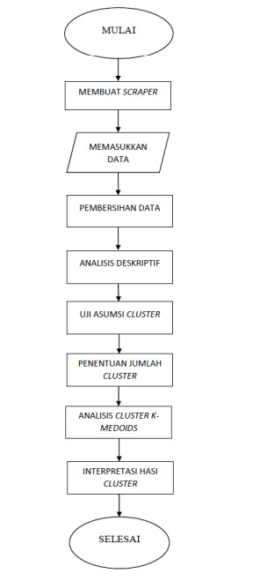
Figure 1. Research methodology diagram

- RESULTS AND DISCUSSION
In this section, we present the research results chronologically, starting from the data preparation stage, the normalization process, the calculation of distances to medoids using the Manhattan metric, to the analysis of cluster stability before and after the presence of outliers. All computational stages and visualization of our clustering results were implemented using Python programming to ensure the repeatability of the experiment, while we used manual calculations based on Excel spreadsheets as a means of conceptual validation of the system output. We developed this cluster analysis approach and performance evaluation method by referring to clustering research practices that emphasize structural stability and the relevance of interpreting the results for managerial decision-making [6].
3.1 Results of normalization and initial data formation
The initial stage of our research began with normalizing the price and review rating attributes using the Min–Max Normalization method to equalize the scale of both variables and prevent the dominance of one attribute in the distance calculation. The maximum and minimum values we used were 2886 and 13 for the price attribute, and 100 and 60 for the review rating attribute.
Normalization is expressed by the following equation:
$$X^{'}=\frac{X-X_{min}}{X_{max}-X_{min}}$$
For example, for data with ID 1, which has a price value of 975 and a review rating of 95, the calculation results in a PRICENORM value of 0.3348 and a REVIEWNORM value of 0.875. These values are consistent with the results recorded in the Excel spreadsheet and we use them as the basis for calculating the distance to the medoid .
3.2 Results of Manhattan distance calculations and cluster determination
We determined our initial medoids from three data objects, ID 899, ID 192, and ID 177, which were selected as initial representations of cluster centers. For each data object, we calculated the distance to the three medoids using the Manhattan metric. We chose this metric because it measures the absolute difference between attributes and is relatively stable against the influence of extreme values in numerical data.
The Manhattan distance equation we use is stated as follows:
$$d\left(x_{i},m_{j}\right)=\left|x_{i1}-m_{j1}\right|+\left|x_{i2}-m_{j2}\right|$$
where xi1x_{i1} xi1 ​and xi2x_{i2} xi2 ​denote the normalized value of price and review rating of the i-th data, respectively , while mj1m_{j1} mj1 ​and mj2m_{j2} mj2 ​denote the normalized value of the j-th medoid.
As an illustration, for data ID 1 with a PRICENORM value of 0.3348 and a REVIEWNORM of 0.875, and medoid 1 (ID 899) which has a price normalization value of 0.30 and a review rating of 0.90, the Manhattan distance is calculated as follows:
$$d_{1}=\left|0.3348-0.30\right|+\left|0.875-0.90\right|$$
The calculation results in a distance value of 0.0598. The same procedure is applied to calculate the distance to medoid 2 and medoid 3. The smallest distance value is used as the basis for determining cluster membership, while this value is recorded as the cost of the data in question.
3.3 Iteration table and evaluation of total cluster cost
After all data has been allocated to the cluster, we calculate the total cluster cost as the sum of the costs of each piece of data. This value is used as an indicator to evaluate whether the cluster configuration at a particular iteration is more optimal than the previous iteration.
The total cost equation is expressed as follows:
$$TC=\sum_{i=1}^{n}{d\left(x_{i},m_{c_{i}}\right)}$$
Where TCTC TC denotes the total cluster cost, xix_i xi ​​is the i-th data, and mcim_{c_i} mci ​​is the medoid of the cluster to which the i-th data belongs.

Table 1. Iteration results and medoid updates using Manhattan distance

Table 2. Iteration 2

Table 3 Iteration 3

Table 4. Iteration 4
Based on the table above, the total cost value decreased from the first to the second iteration, indicating that the medoid exchange resulted in a more optimal cluster configuration. In the third iteration, there was no significant change in medoid position or total cost value, so the clustering process was considered to have reached a convergent condition. These results indicate that the K-Medoids algorithm with the Manhattan metric is able to achieve cluster stability in a relatively limited number of iterations.

3.4 Evaluation of Differences in Clustering Results on Data with and without Outliers
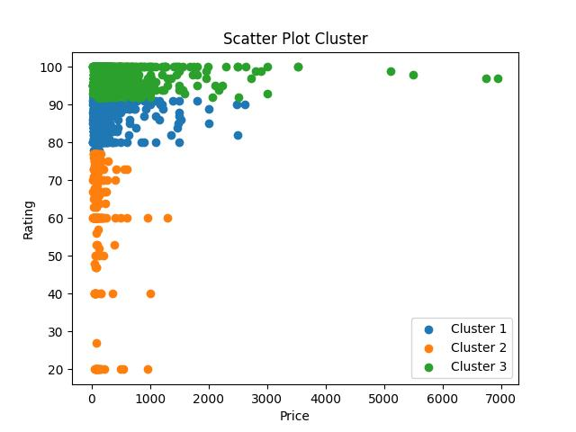
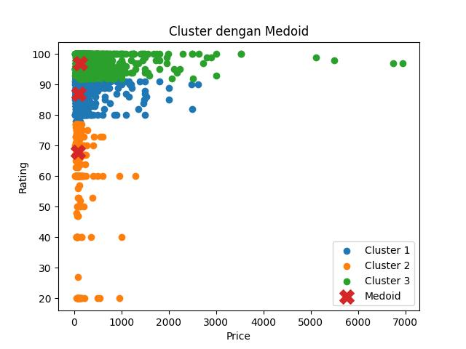
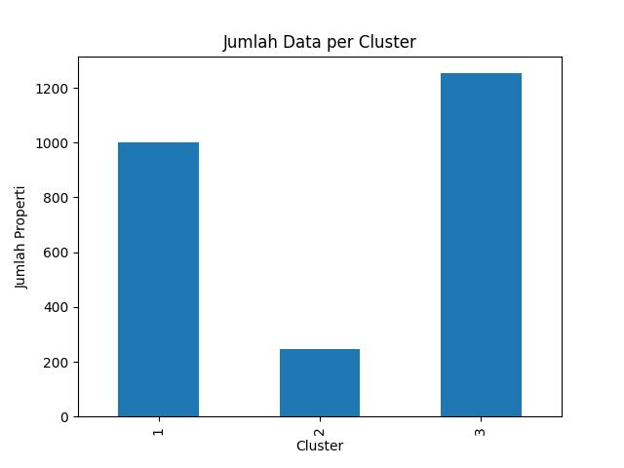
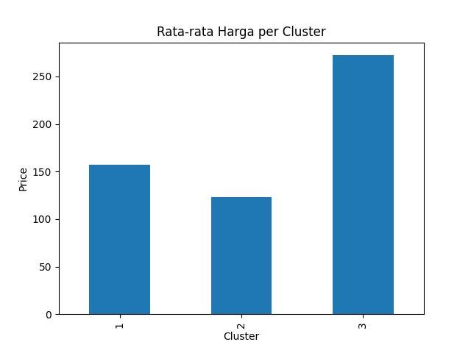
Figure 2. Original Data Without Outliers
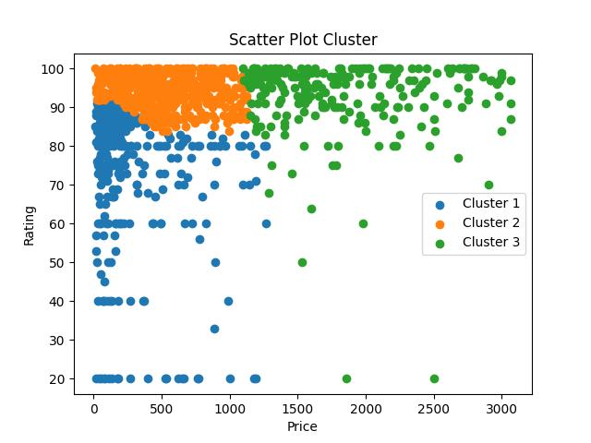
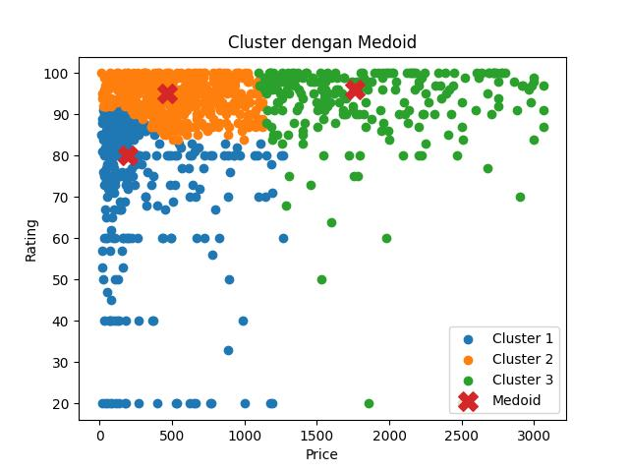
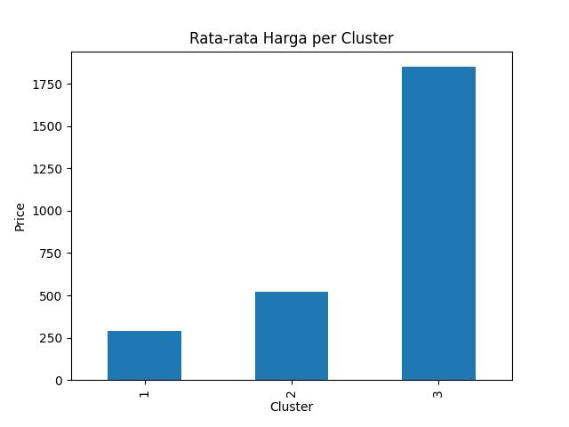
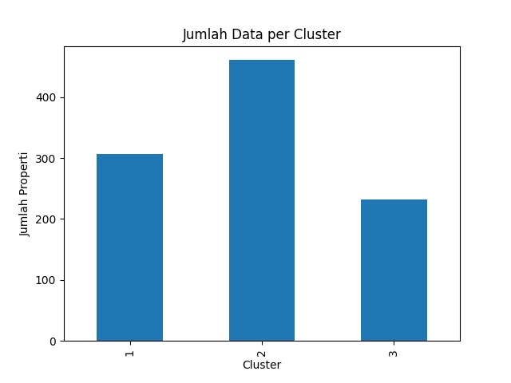
Figure 3. Graph with Outliers
A visual comparison between the original data, which still contains outliers, and the data after extreme value filtering shows that the presence of outliers in the price attribute does not change the basic cluster structure generated by K-Medoids. In both conditions, the separation pattern remains, forming three main groups based on price levels: low, medium, and high. While the very high price points in the original data appear visually separated, the medoids remain at the center of the normal data density and are not attracted to these extreme values. This indicates that K-Medoids remains structurally stable, as the cluster centers are determined by representative objects, not averages that are easily shifted by outliers. Cost values also do not show drastic pattern changes, thus maintaining the consistency of cluster formation despite the presence of extreme values.
In terms of managerial interpretability, the cluster characteristics before and after outlier removal remain consistent. The first cluster represents low-priced properties with a wider variation in ratings, the second cluster depicts mid-range properties with relatively high ratings, and the third cluster reflects premium properties with high prices and excellent ratings. This means that the business meaning of each cluster remains unchanged even though the data contains significant outliers. The resulting segmentation remains relevant for management decisions, such as determining pricing strategies, service differentiation, and market targeting. Thus, K-Medoids is proven to be robust against outliers in Airbnb management data because it is able to maintain the stability of the cluster structure while maintaining consistency in managerial interpretation.
This finding is also supported by various previous studies which show that K-Medoids has high stability against noise, data variation, and the presence of outliers in various application contexts [7]–[15].
4. THANK YOU
The author expresses his appreciation and gratitude to the lecturers and supervisors of the Machine Learning course for their guidance, direction, and constructive feedback during the research and preparation of this manuscript. He also expresses his gratitude to the institutions and relevant parties who provided writing guidance and academic facilities to support this research. Furthermore, he expresses his appreciation to the public data providers who have made the datasets available openly, enabling this research to be conducted transparently, verified, and replicable by other researchers.

- BIBLIOGRAPHY
[1] N. Sureja, “An improved k-medoids clustering approach based on crowd search algorithm,” Results in Control and Optimization, vol. 8, 2022.
[2] A. AbdElSamea et al., “K-medoid clustering containerized allocation algorithm for robust performance against noise and outliers,” Cogent Engineering, vol. 11, 2024.
[3] AZ Apridayanti et al., "An implementation of K-Medoids method in provincial clustering," Jurnal Varian, vol. 7, no. 1, 2024.
[4] MD Salman, “Comparison of K-Means and K-Medoids clustering,” Malcom Journal, 2025.
[5] CBG Allo, “Performance of single linkage and K-Medoids on data with outliers,” Sinkron Journal, 2024.
[6] S. Yousif, “Application and evaluation of a K-Medoids-based shape clustering method,” Journal of Computational Design and Engineering, vol. 8, 2021.
[7] AM Leis et al., “K-medoids clustering of hospital admission characteristics,” BMC Medical Informatics and Decision Making, vol. 23, 2023.
[8] C. Huang and N. Tsutsumida, “A scalable k-medoids clustering via whale optimization algorithm,” arXiv, 2024.
[9] Y. Hasnataeni, “Comparison of clustering analysis,” JOSCEX, 2025.
[10] N. Qona'ah, "Laboratory clustering using K-Means, K-Medoids, and models," IJAS Journal, 2023.
[11] “Outlier detection from clustering results using the K-Medoids algorithm,” JOSYC, 2024.
[12] DR Edmondson, PA Albinsson, and CD Hopkins, “K-Medoids clustering for mixed data,” 2024.
[13] L.R. de Amorim and M. Hennig, “Recovering the number of clusters in data sets with noise features using feature rescaling factors,” Information Sciences, vol. 324, pp. 126–145, 2015.
[14] E. Schubert and A. Zimek, “ELKI: A software system for evaluation of subspace clustering algorithms,” Data Mining and Knowledge Discovery, vol. 33, no. 3, pp. 765–795, 2019.
[15] M. Ester, H.-P. Kriegel, J. Sander, and X. Xu, “A density-based algorithm for discovering clusters in large spatial databases with noise,” Data Mining and Knowledge Discovery, vol. 2, pp. 169–194.

